Math 327 - Chapter 14 Homework 1, Michael Streyle

Plot the logistic mean function, $E\{Y\}=exp(β_{0}+β_{1}X_{1})/(1+exp(β_{0}+β_{1}X_{1}))$, when $β_{0}=-25$ and $β_{1}=0.2$.

X = seq (90, 150)  
fitprob = exp(-25 + 0.2*X) / (1 + exp(-25 +0.2*X))  
plot(X, fitprob, main='Logistic Mean Function')  
lines(X, fitprob)

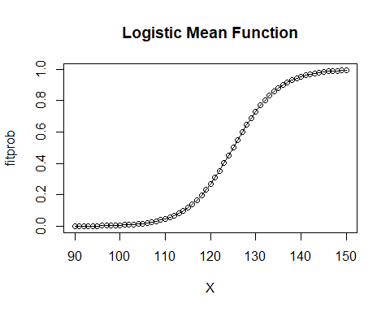

What is the predicted proabability for X=115? The predicted probability for X=115 is 0.1192.

Xj = 115  
exp(-25 + 0.2*Xj) / (1 + exp(-25 + 0.2*Xj))

## [1] 0.1192029

For what value of X is the mean response equal to 0.5? (Solve for X algebraically, then calculate in R)

The mean response is equal to 0.5 when X = 125.

X_5 = (log(0.5/(1-0.5)) + 25)/0.2  
X_5

## [1] 125

Find the odds when $X=130$, when $X=131$, and the odds ratio for X=131 vs. X=130. Verify that this odds ratio is equal to $exp(β_{1})$.

The odds when X=130 and when X=131 are 2.718 and 3.3201 respectively. The odds ratio between X=130 and X=131 is 1.2214. This is confirmed when you calculate exp(0.2), which also is equal to 1.2214 as seen in the knitted code.

Xk = c(130, 131)  
fitprob2 = exp(-25 + 0.2*Xk) / (1 + exp(-25 +0.2*Xk))  
fitprob2

## [1] 0.7310586 0.7685248

odds2 = fitprob2 / (1 - fitprob2)  
odds2

## [1] 2.718282 3.320117

odds.ratio = odds2[2] / odds2[1]  
odds.ratio

## [1] 1.221403

exp(0.2) #demonstrates the interpretation of the slope in logistic regression

## [1] 1.221403

A psychologist conducted a study to examine the nature of the relation, if any, between an employee's emotional stability (X) and the employee's ability to perform in a task group (Y). Emotional stability was measured by a written test for which the higher the score, the greater is the emotional stability. Ability to perform in a task group (Y = 1 if able, Y = 0 if unable) was evaluated by the supervisor.

taskperf = c(0, 0, 0, 1, 1, 0, 0, 1, 1, 1, 1, 1, 1, 0, 1, 0, 1, 0, 1, 0, 0, 0, 1, 0, 1, 0, 1)   
  
emostab = c(474, 432, 453, 481, 619, 584, 399, 582, 638, 624, 542, 650, 553, 425, 563, 549, 498, 520, 610, 598, 491, 617, 621, 573, 562, 506, 600)  
  
plot (emostab, taskperf, main='Psychologist Study Plot', xlab="Emotional Stability", ylab="Task Performance")  
  
lines (lowess (taskperf ~ emostab), col='red')  
logistic.fit = glm (taskperf ~ emostab, family=binomial)  
  
summary (logistic.fit)

##   
## Call:  
## glm(formula = taskperf ~ emostab, family = binomial)  
##   
## Deviance Residuals:   
## Min 1Q Median 3Q Max   
## -1.7845 -0.8350 0.5065 0.8371 1.7145   
##   
## Coefficients:  
## Estimate Std. Error z value Pr(>|z|)   
## (Intercept) -10.308925 4.376997 -2.355 0.0185 *  
## emostab 0.018920 0.007877 2.402 0.0163 *  
## ---  
## Signif. codes: 0 '***' 0.001 '**' 0.01 '*' 0.05 '.' 0.1 ' ' 1  
##   
## (Dispersion parameter for binomial family taken to be 1)  
##   
## Null deviance: 37.393 on 26 degrees of freedom  
## Residual deviance: 29.242 on 25 degrees of freedom  
## AIC: 33.242  
##   
## Number of Fisher Scoring iterations: 4

betahat = coefficients(logistic.fit)   
emostab.seq = seq(400, 650, by=5)  
X <- cbind(1, emostab.seq)  
Xb <- X %*% betahat  
prob = exp(Xb)/(1+exp(Xb))  
lines(emostab.seq, prob, col='blue')

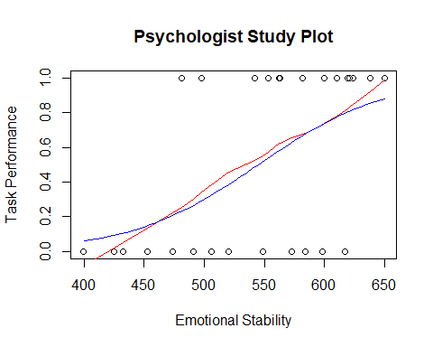

exp(0.018920)

## [1] 1.0191

Obtain $exp(β_{1})$ and interpret that number.

The slope coefficient for X1 (emotional stability) is 0.018920, and so $exp(β_{1})$ is 1.0191 which is interpretted as the odds ratio corresponding to a one unit change in X1. This means that the odds of being able to take part in a task group increase by 1.91 percent with each additional unit increase in emotional stability score.